DIP CRYSTAL UNITS
ZC-M49 Seam Sealing Crystal
. Very corthpact and thin(7.5*4.0*2.3mm MAX)
. Frequency range of 3M～64M with Found
. Low cost ,Wide frequency range,Excellent aging
1 | Nominal Frequency  标称频率 | 3～64MHz
2 | Holding  封装形式 | ZC-M49
3 | Vibration Mode  振动模式 | AT CUT,FUND/3RD  AT切,基波/三倍波
4 | Frequency Tolerance @ 25±3℃  调整频差 | ±10PPM /±20PPM/±30PPM
5 | Frequency Stability@ 6  工作温度条件下的频率容差 | ±10PPM /±20PPM/±30PPM
6 | Operating Temperature Range  工作温度 | -20～+70℃/-40～85℃
7 | Store Temperature Range  存储温度 | -55～+125℃
8 | Equivalency Resistance  等效电阻 | 20～200Ω max
9 | Load Capacitance  负载电容 | 10～32PF
10 | Drive Level  激励功率 | 100μW max
11 | Insulation Resistance  绝缘阻抗 | ＞500MΩ at DC 100V±15V
12 | Aging  老化 | ±3PPM/year max

CRYSTAL CERAMIC DIP 49SS/SMD DIMENSION
PACKAGE DIMENSIONS:Unit: mm
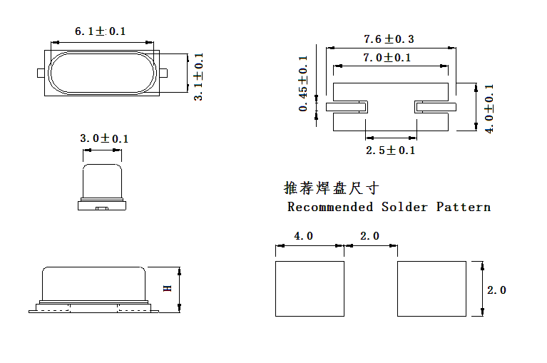
NO. | 规格 | H
1. | F<16Mhz(含) | 2.3Max
2 | F>16Mhz | 2.1Max

